**1) folder setup**

1. create empty asp.net core project
2. solution created now delete project
3. inside it create folders and projects using class library (layers)
4. remove classes eg class1,class2 etc
5. build solution by clicking on build tab
6. set WebAPi as startup project
7. run by play btn

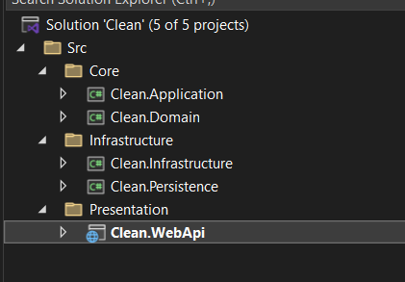

1. **add project refrence & DI**
   1. add refrence by clicking on dependencies

domain: no one

application : domain

infrastructure: application

persistence: application

api(presentation):app,per,inf

* 1. add below package in application layer for di (latest)



* 1. create service extension class in Extensions folder app,inf,persis and register in program.cs

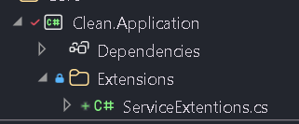

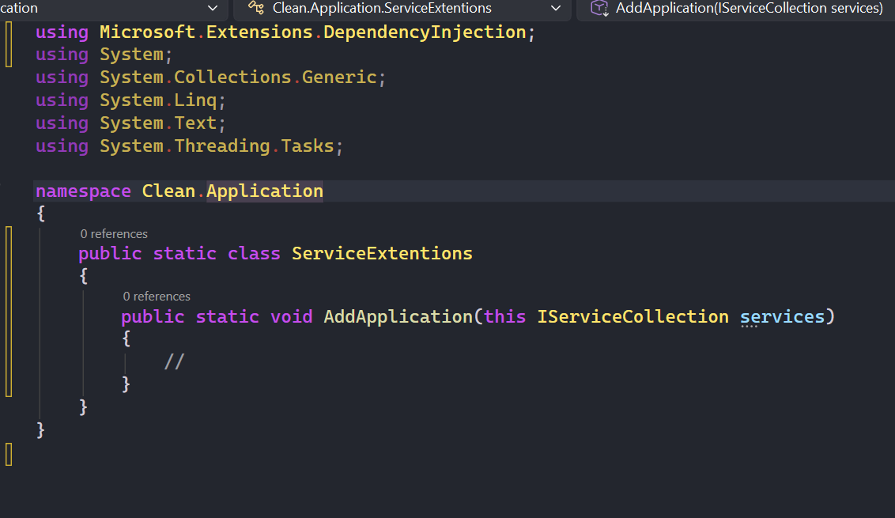

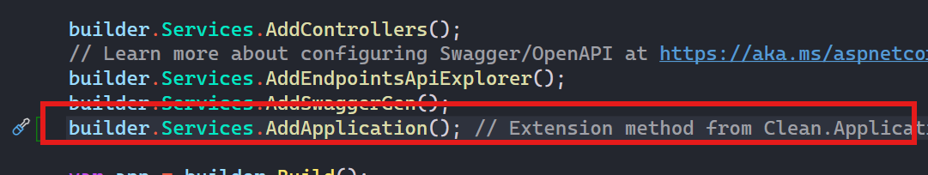

* For all 3

1. Install mediatr in application layer (latest) if old also install di

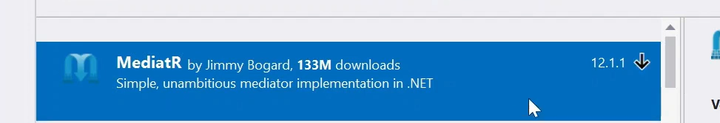

1. Register mediatr in application layer service extension

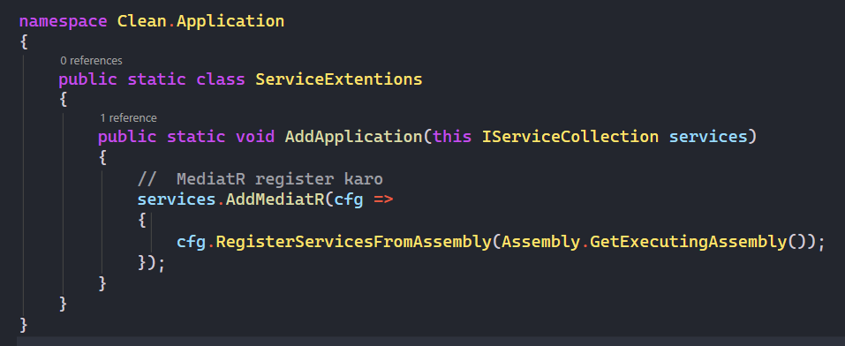

1. Create folder structure note feature can change according to project inside it command and query folder

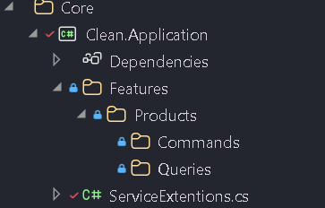

1. Create command / query for product check **commit 2** for details:

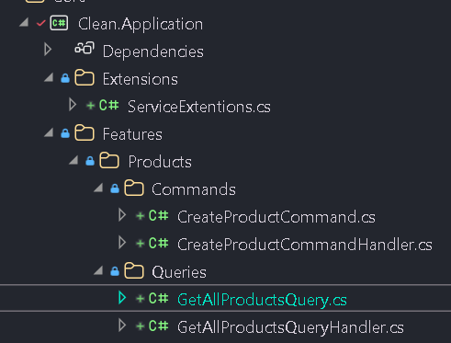

1. Create controller and inject mediatr and create end point check

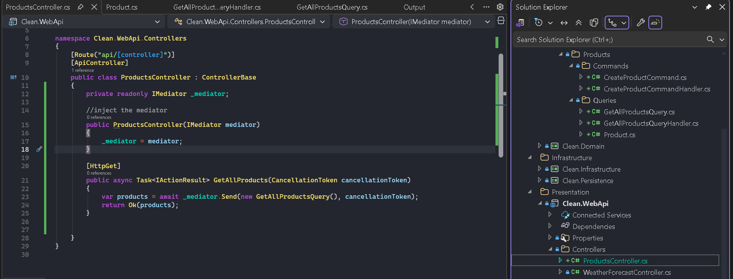

1. Adding ef core and setting up domain layer etc check **commit3** for details

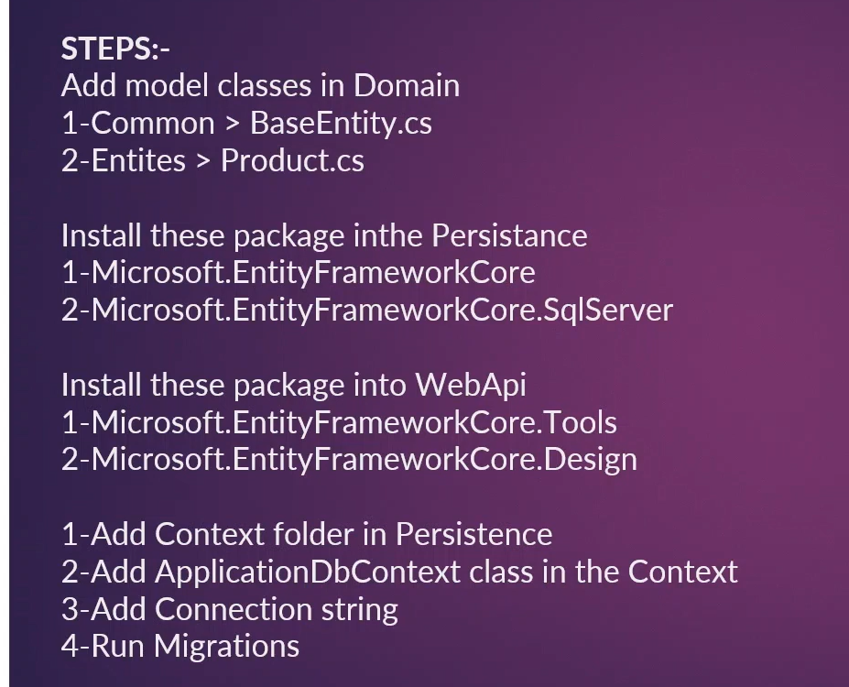

Crud operations

Create interface in application layer

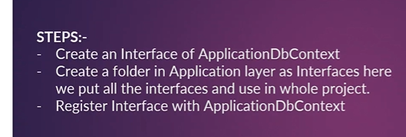

Put all prop / functions in interface

Install ef core package

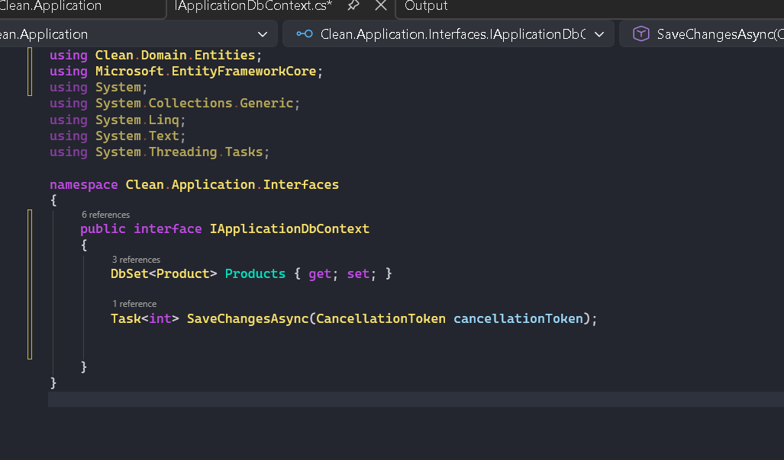

Inherit application db context with interface we created

Register in service extension in persistence

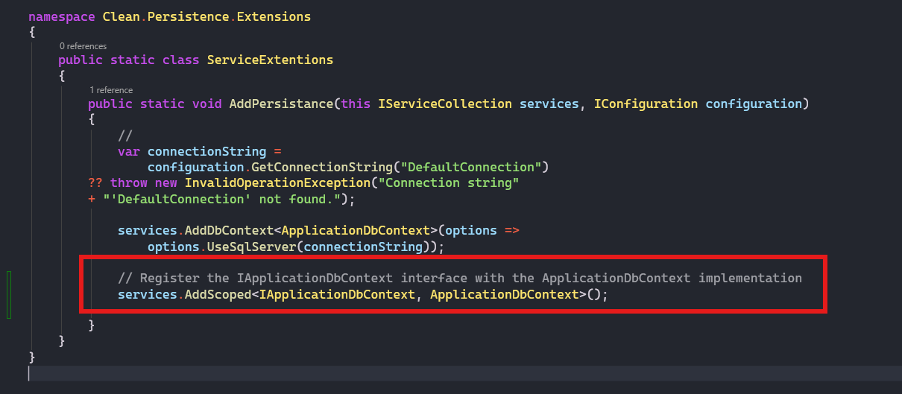

Now crud for this check handlers/commands etc and controller in commit 4

Automapper

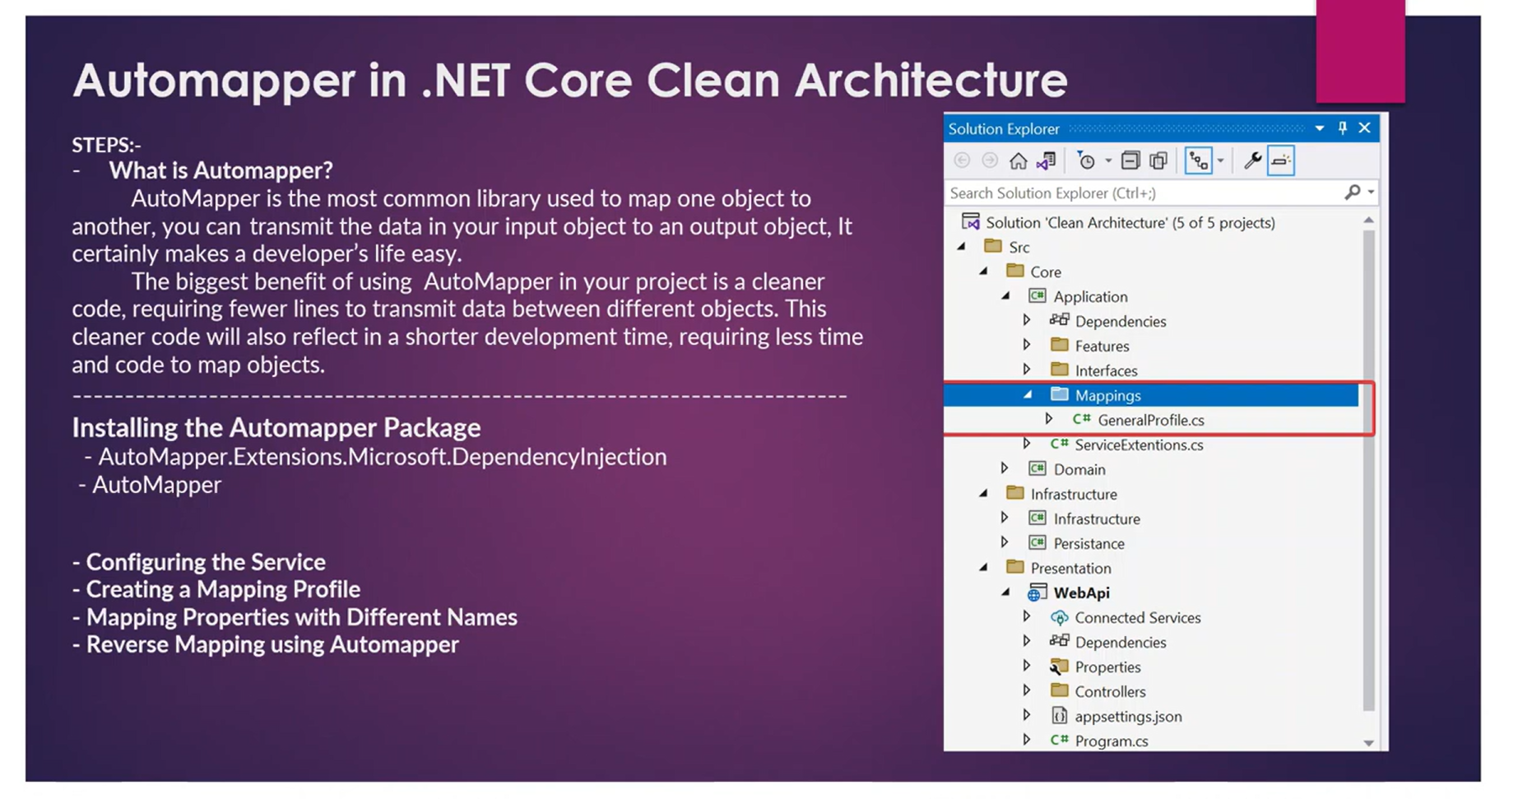



Install package in application layer

Register in application layer extension method

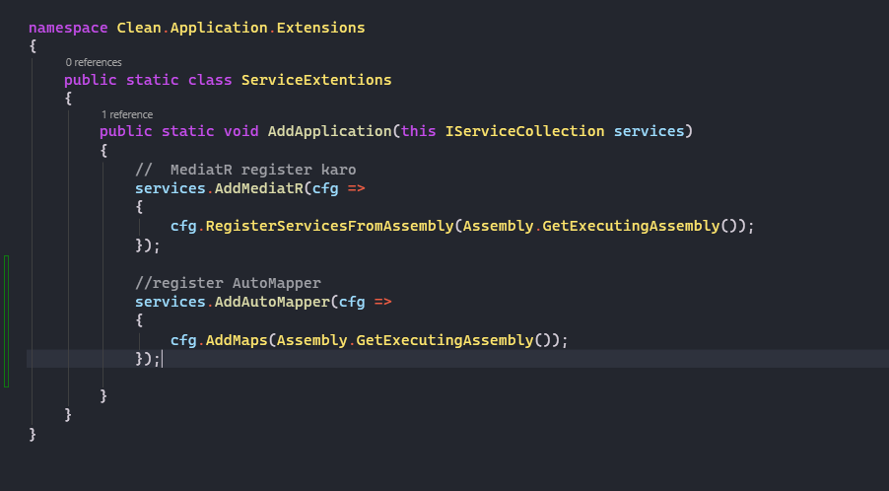

Create mapping profile folder and inside it class in app layer

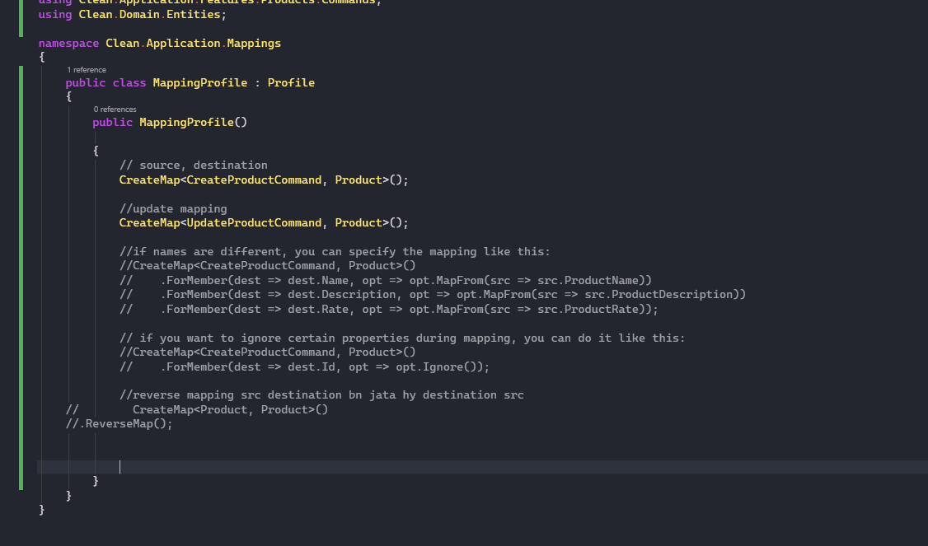

Update the mapping

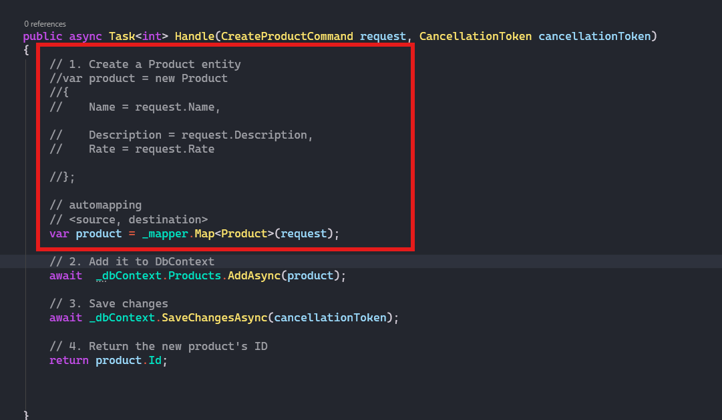

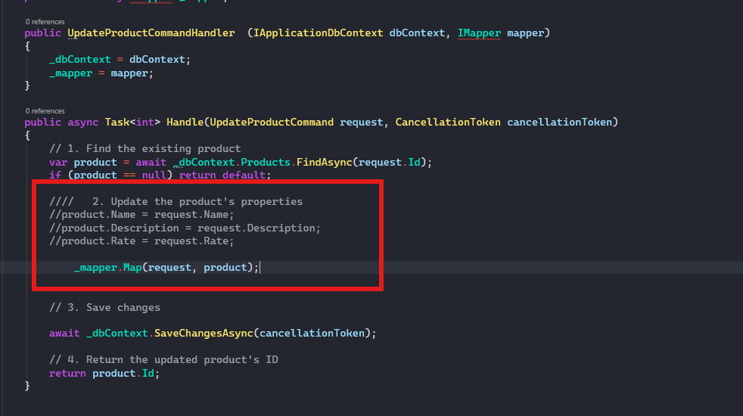

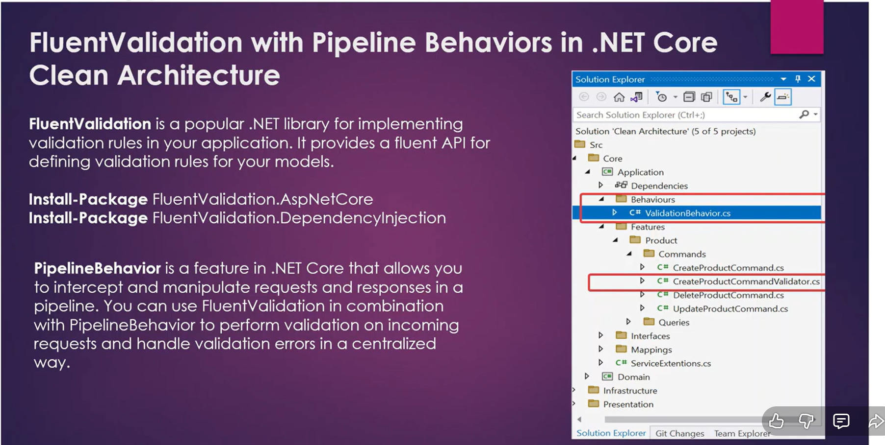

Install packages in application layer

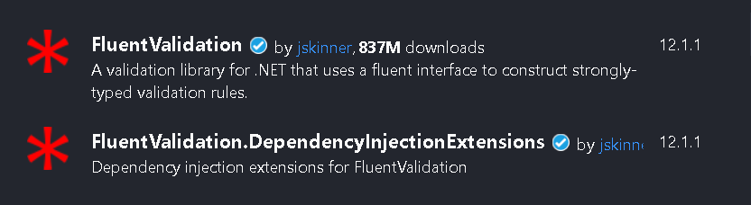

Register in service extension of application layer

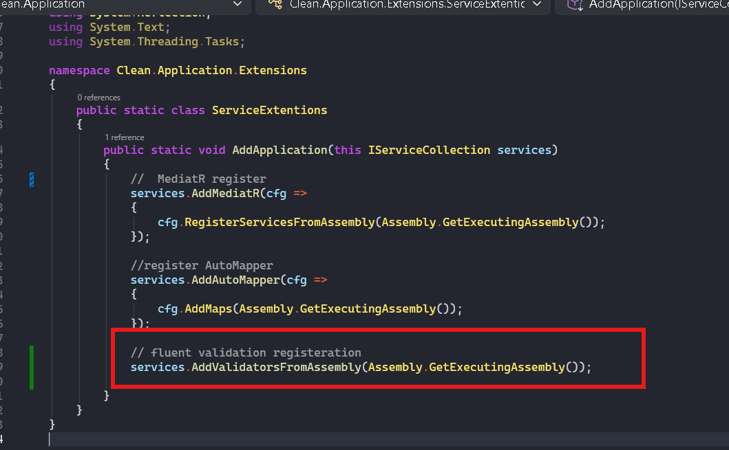

Create validator for create command for now create as your needs

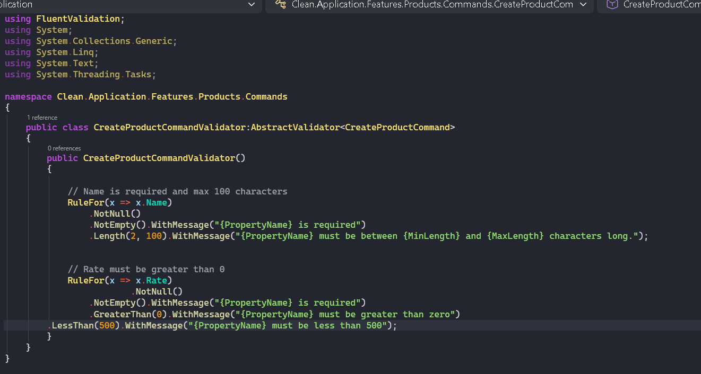

Now create behaviour

This is boilerplate logic to handle validations

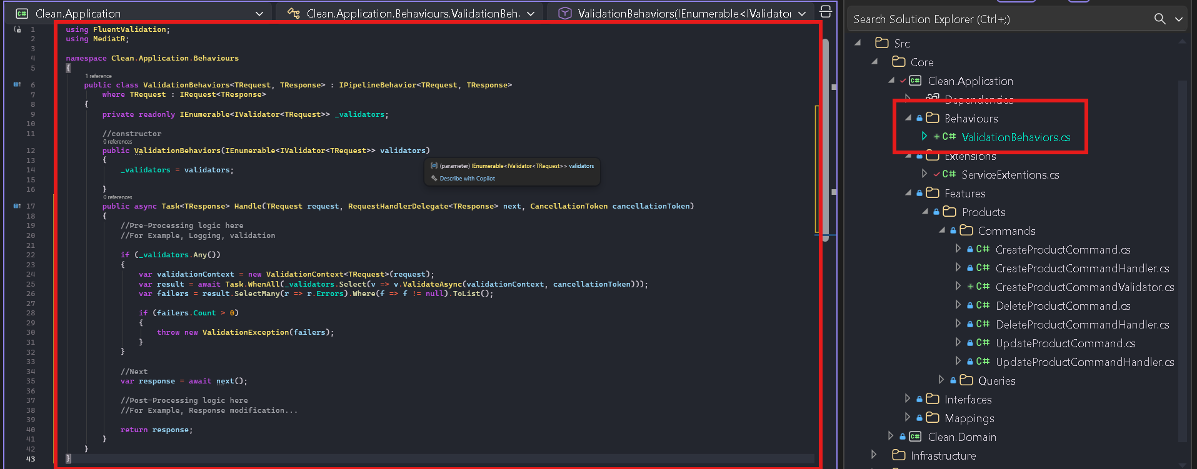

Register in service extensions

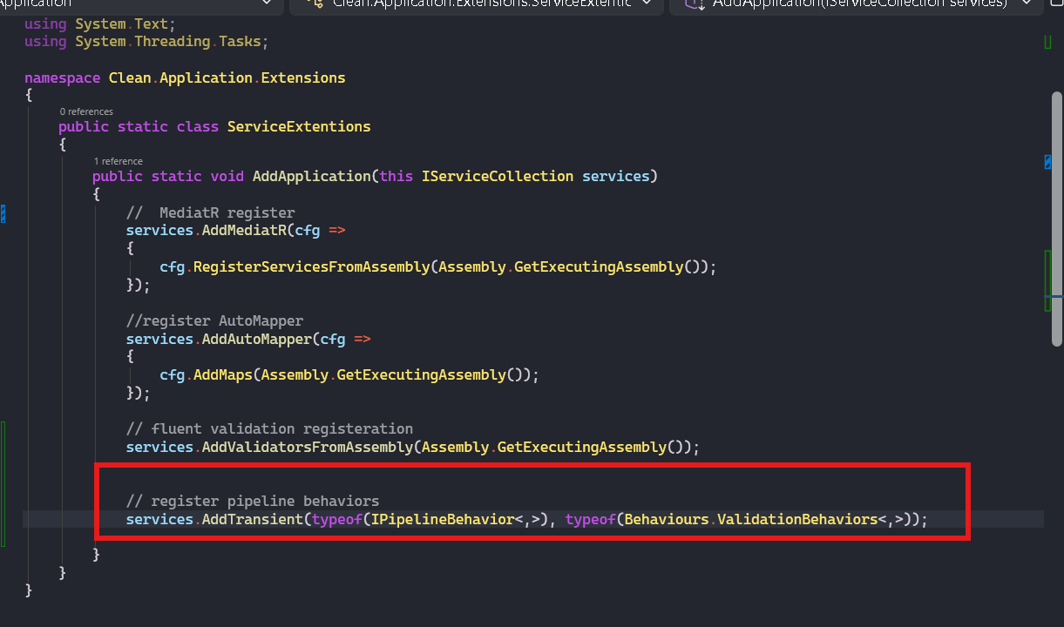

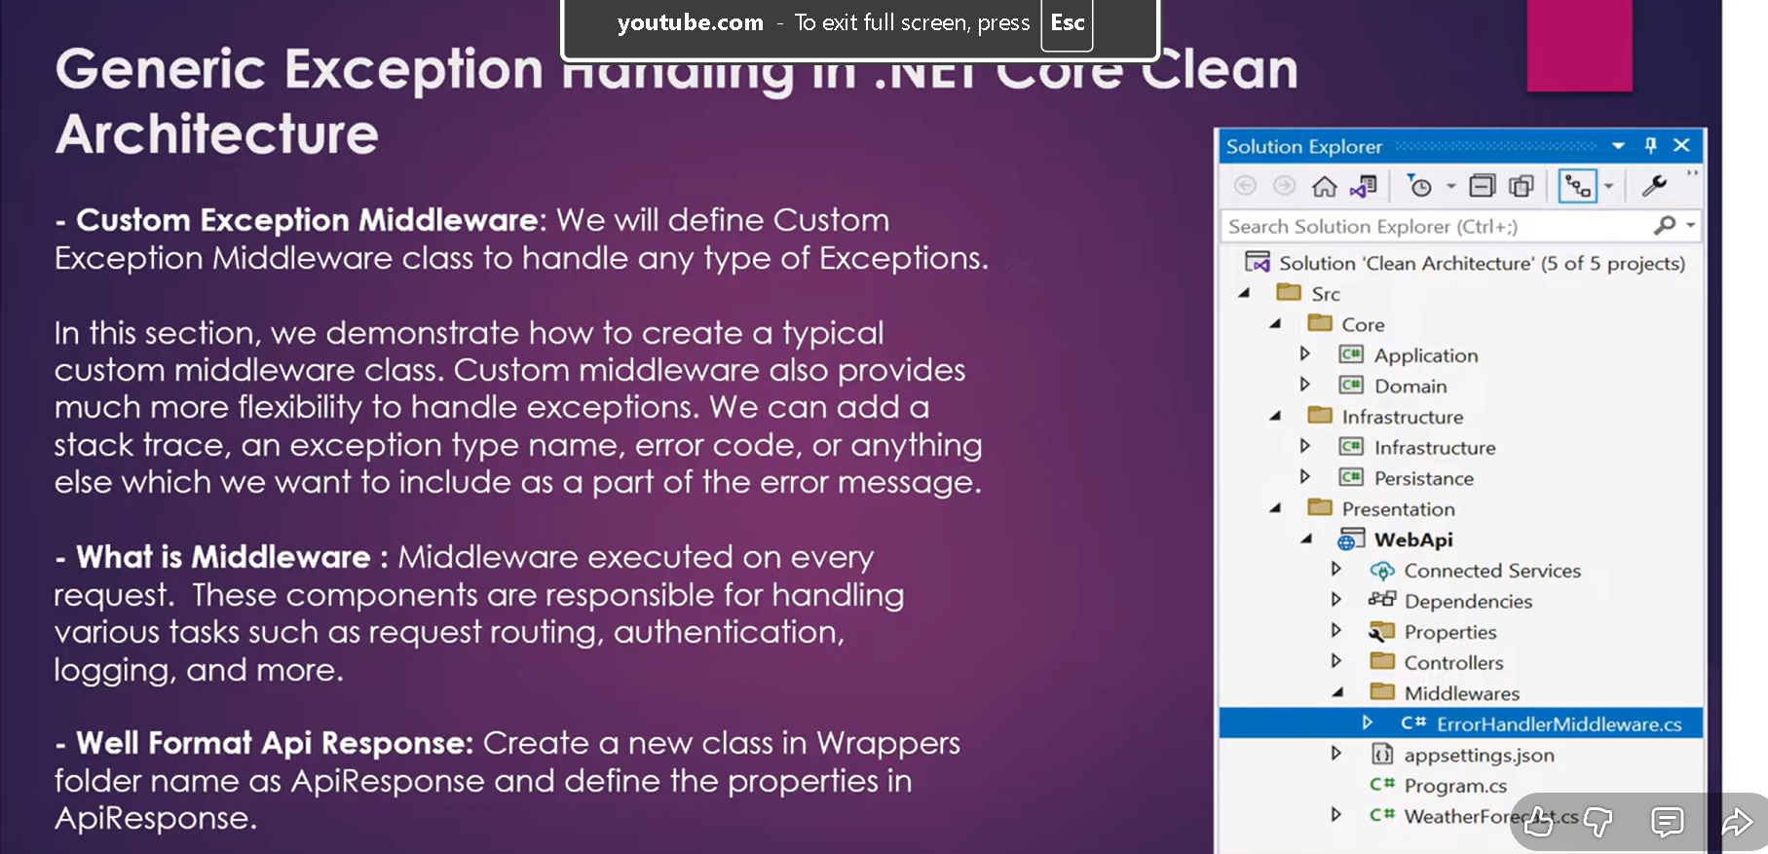

Create this in app layer

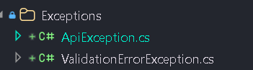

Api to handle api exceptions   
validations to handle fluent validation errors custom class

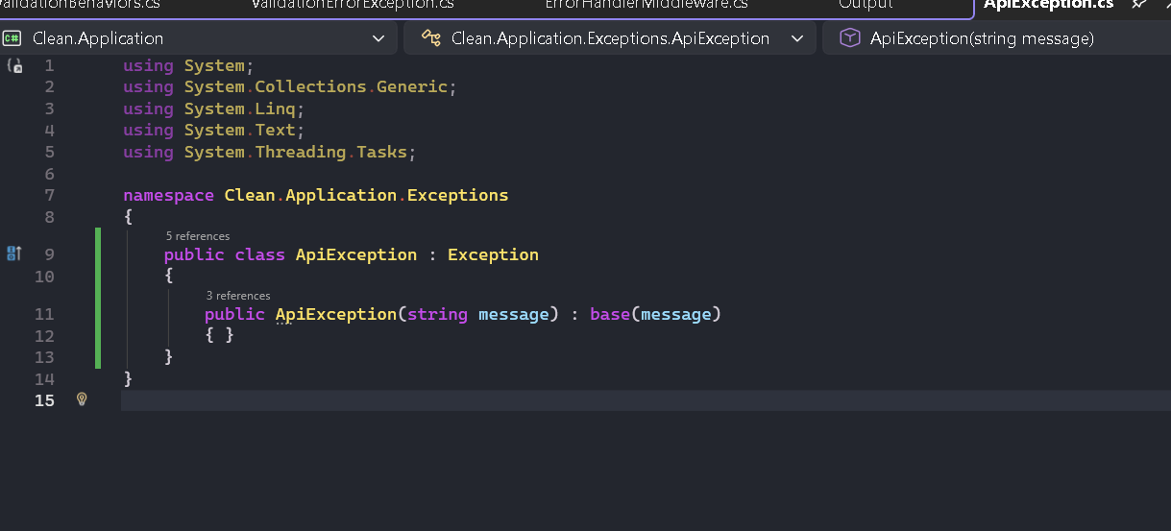

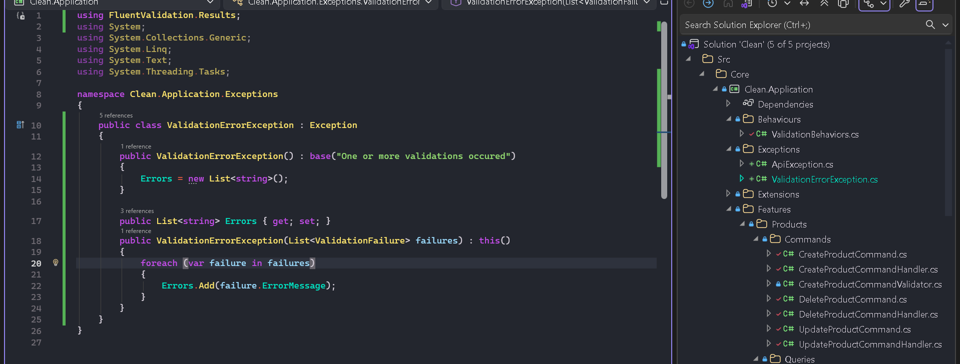

Create in app layer



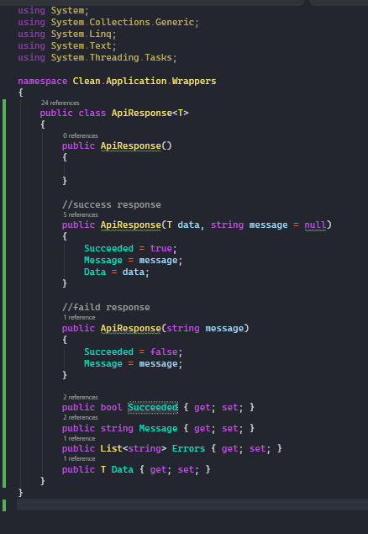

Create in web api presentation layer

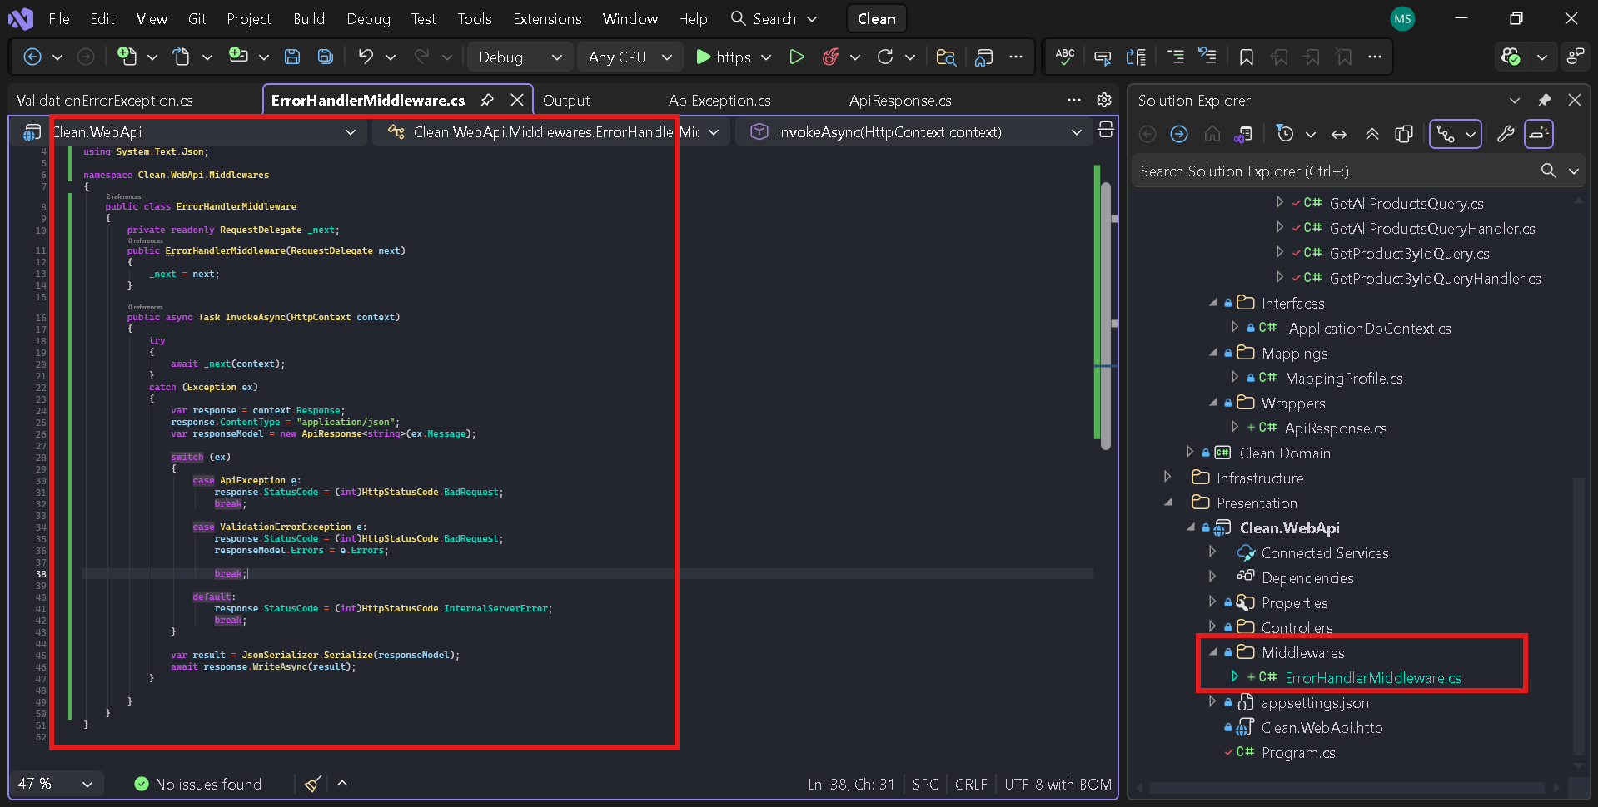

In program.cs

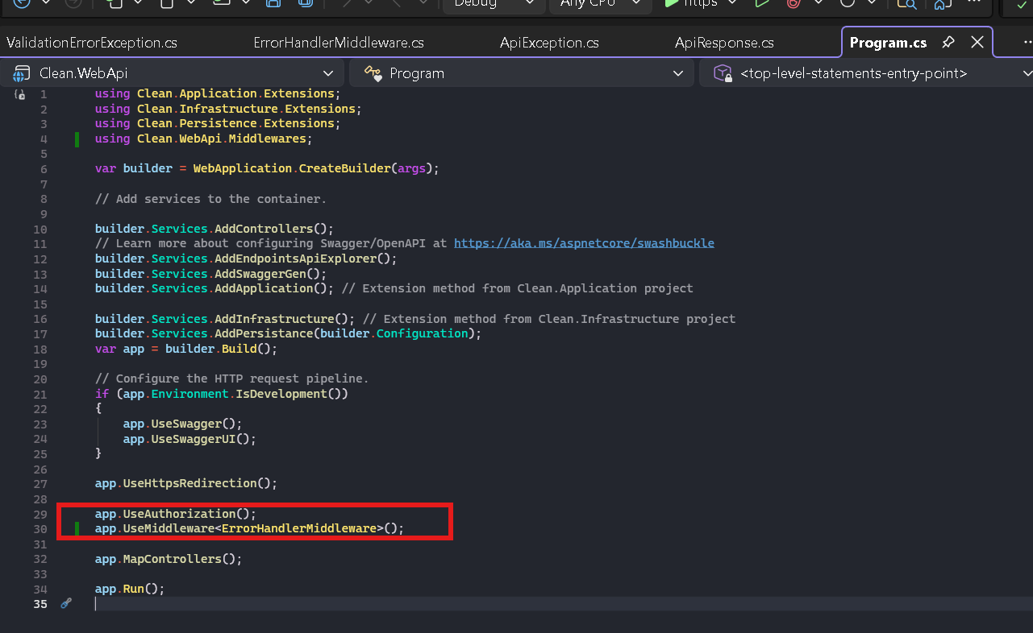

Now update handlers for all check all fr details only shhhow one for now

